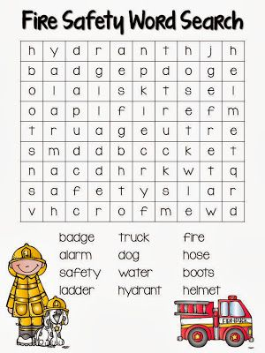
https://i.pinimg.com/736x/86/a6/39/86a639791007ea26b381b930d19a6f51--fire-safety-crafts-fun-math.jpg

