Big 6 Severe Weather
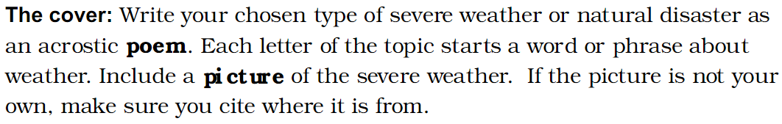

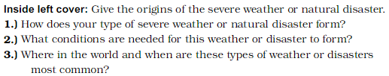

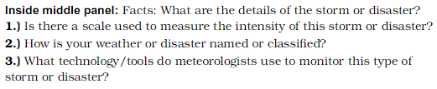

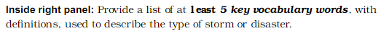

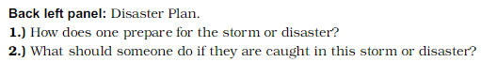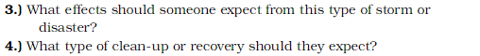

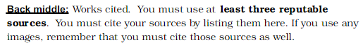

Ondrive.Q2.4 wackyweather

